**Beehive Traffic**

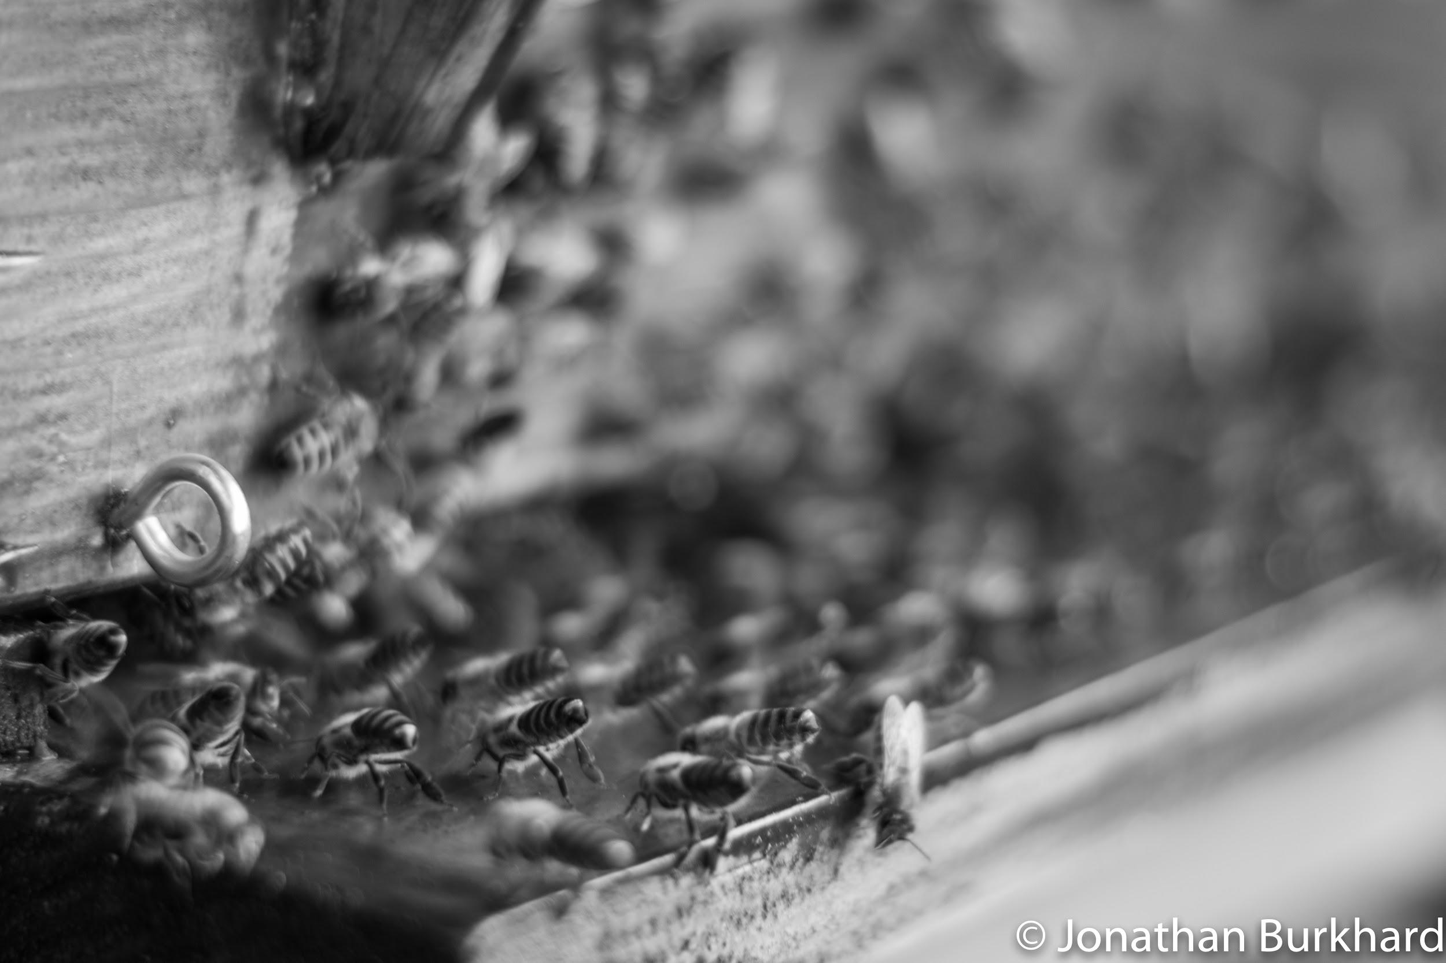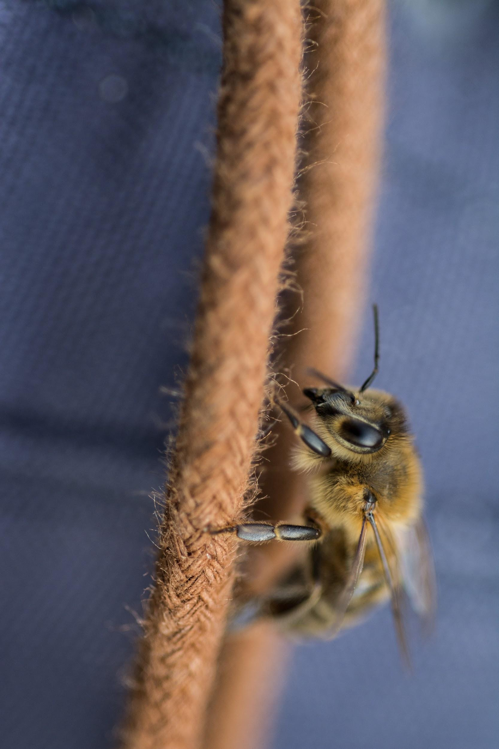

Description:

One problem that a beekeeper can encounter in spring, is the sudden swarming of his bees. They do so to find a new location for their colony.

In this project we want to count the number of bees that enter and leave the hive at any particular time, in order to develop a system which can detect the possibility of a swarming.

Goal: The goal of the project is to be able to automatically count the number of bees entering and leaving a hive using a single camera and applying an appropriate image processing algorithm to the video.

Method: In order to achieve this we will attach a camera, preferably a GoPro, to the hive and take several videos of the hive entrance. In order to count the incoming and leaving bees we will implement a tracking system, using background subtraction and segmentation with ellipse fitting.

Tools: Python, OpenCV, Colmap, GoPro, Hive, Bees

Planning:

|  |  |  |  |
| --- | --- | --- | --- |
| **Tasks** | **Responsibility** | **Starting date** | **Time period** |
| Literature research | Everyone | Week 3 | 1 week |
| Get familiar with Python, OpenCV and Colmap | Everyone | Week 3 | 2 weeks |
| Find which hive we will use for the video  Talk to people in Zürich | John | Week 4 | 1 week |
| Calibrate cameras   * Frame to frame association * Mapping image to world | Philipp, Julie | Week 4 | 2 weeks |
| Test installation: different positions of camera and paper for uniform background | John | Week 5 | 2 weeks |
| Background Subtraction | John | Week 6 | 1 week |
| Prepare slides | Everyone | Week 7 | 1 week |
| Midterm presentation | Everyone | Week 8 |  |
| Implement segmentation and tracking | Jasmin, Philipp | Week 8 | 2 weeks |
| Determine logic to count incoming and outcoming bees | Julie | Week 10 | 1 week |
| Write Report | Everyone | Week 12 | 2 weeks |
| Prepare slides for final presentation | Everyone | Week 13 | 1 week |
| Final Presentation | Everyone | Week 14 |  |